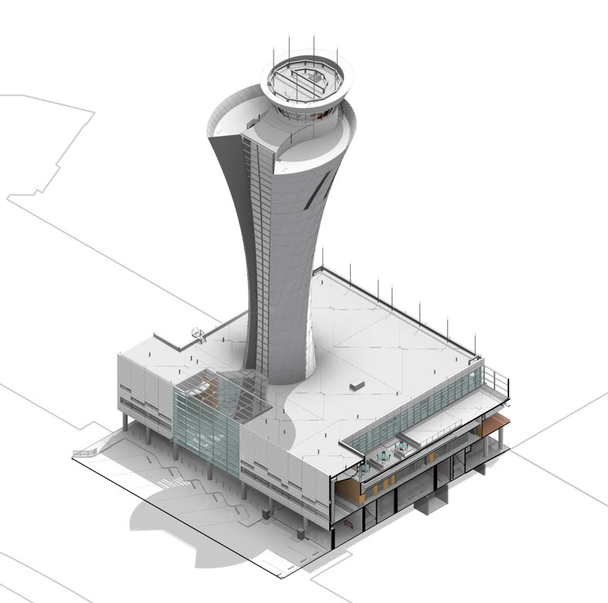

**Revit Standard**

Version Date: December 2018

☑ - Checkmark indicates Large Capital Project requirement

1 Introduction 4

1.1 Model Verification and Quality Assurance 4

1.1.1 Verification of Model Geometry ☑ 4

1.1.2 BIM Projects Quality Assurance ☑ 4

1.2 Abbreviations and Acronyms 4

2 BIM Management 5

2.1 General Model Requirements 5

2.1.1 Site Design 5

2.1.2 Model Audits ☑ 5

2.1.3 Conformed Model ☑ 5

2.2 Model File Naming Conventions ☑ 5

2.3 SFO Revit Templates 6

2.3.1 Transfer Project Standards 6

2.4 Central Files and Local Files 7

2.4.1 Central Files 7

2.4.2 Local Files 7

2.5 Coordinate System Alignment ☑ 8

2.6 Container Concepts 8

2.6.1 Master Detail Containers 8

2.7 Model Maintenance 10

2.8 Archiving and Upgrading Requirements 10

2.8.1 Archive the Models 10

2.8.2 Manually Upgrade File-based Workshared Project 10

3 Model Organization - Project Setup 12

3.1 Views 12

3.1.1 View Creation 12

3.1.2 MEP Views and Analytical Views 12

3.2 Worksets 12

3.2.1 Worksets for Scoped Work 14

3.2.2 Worksets for Linked Files ☑ 14

3.2.3 Worksets for Disciplines 14

3.3 Links 15

3.3.1 Single Discipline Model Linking ☑ 15

3.3.2 Multidiscipline Model Linking ☑ 15

3.3.3 Linking Guidelines ☑ 16

3.3.4 Linking CAD Files ☑ 16

3.3.5 Importing CAD ☑ 16

3.4 Levels and Grids 17

3.4.1 Levels ☑ 17

3.4.2 Grids ☑ 17

3.5 Copy Monitor 18

3.5.1 Copy/Monitoring Standards 18

3.5.2 Copy/Monitoring Best Practices 18

3.6 Phases 19

4 Browser Organization 20

4.1 Views (SFO View Browser) ☑ 20

4.1.1 View Naming 20

4.1.2 View Series and View Type 21

4.1.3 Starting View 21

4.1.4 Working Views 22

4.2 Sheets (SFO Project Browser) 23

5 Graphic Settings 24

5.1 Titleblocks and Sheets ☑ 24

5.2 View Templates and View Filters 25

5.2.1 Color Codes for Mechanical Systems ☑ 25

5.2.2 Color Schemes 28

5.2.3 Area Plans 28

5.2.4 Departments 28

5.2.5 Object Styles 28

6 Model Content 31

6.1 Families 31

6.1.1 Family Creation Guidelines 31

6.1.2 Family Naming ☑ 31

6.1.3 Coordination with Families 32

6.1.4 Connectors 32

6.2 Parameters 34

6.2.1 Parameter Creation Guidelines 34

6.2.2 Project Parameters 34

6.2.3 Family Parameters 34

6.2.4 Shared Parameters 34

6.2.5 Global Parameters 34

6.3 Schedules and Coordination Schedules 35

6.3.1 Schedules ☑ 35

6.3.2 Coordination Schedules 35

6.4 Electrical Panel Schedules 37

6.4.1 Panel Schedule Overview ☑ 37

6.4.2 Creating Panel Schedules 38

6.4.3 Managing Panel Schedules 39

6.5 Modeling Requirements 40

6.6 Mechanical Systems Analysis 42

6.6.1 System Inspector 42

6.6.2 Analysis Visibility Override 42

6.7 Detailing Standards 43

6.7.1 Creating Details 43

6.7.2 Converting CAD Details 43

7 Appendices 46

7.1 Abbreviations and Acronyms 46

7.2 Family Creation Guidelines 46

7.3 View Naming Guidelines 46

7.4 Change Request 46

8 Attachments 46

8.1 Sheet Numbering Standard 46

8.2 Coordinate System Setup 46

☑ - Checkmark indicates Large Capital Project requirement

1. Introduction

The following Revit standards are applicable to the documentation, modeling, and deliverables of the San Francisco International Airport International Airport, hereinafter referred to as “Airport,” projects. These standards form the baseline for all Revit deliverables produced by the Airport Capital Projects division or by external design contractors. Not all conditions that may be encountered on an Airport project are described and teams must consult their Project Manager or Revit Coordinator to resolve any unique conditions that may arise over the course of the project.

It is understood that external contractors may have their own production standards and that those standards may conflict with this Revit standard. In certain instances, external contractors will be permitted to use their own processes and standards. Where the ☑ is indicated, external contractors are required to follow this standard regardless of their own internal organizational standard.

The content of this document supersedes all previously published Airport Revit Standard versions and is subject to change without notice. The Airport is not responsible for errors and omissions in this Standard.

## Model Verification and Quality Assurance

Refer to the Model Verification Standard for detailed verification requirements.

### Verification of Model Geometry ☑

The Airport utilizes project documents and models for long term operations and maintenance of the facilities and as a starting point for future projects. The Airport expects a high level of accuracy in the documents and a robust verification process used to ensure product quality. The Airport expects to leverage Building Information Model (BIM) outputs for all its design, construction, operations, and maintenance projects. Therefore, all documents generated utilizing BIM must be thoroughly checked using a reliable verification process prior to delivering drawings and models to the Airport.

Refer to the SFO Model Verification Report for further details.

### BIM Projects Quality Assurance ☑

Check all models for the following:

* Geometric accuracy of modeled components in compliance with the BIM Execution Plan
* Location accuracy in the horizontal and vertical dimensions
* Conformance with the Revit standards identified in this document
* Conformance with the “SFO BIM Guide” and model data quality requirements

## Abbreviations and Acronyms

See the appendix for Abbreviations and Acronyms.

1. BIM Management

## General Model Requirements

### Site Design

The Architectural Engineering & Construction (AEC) team members, hereinafter referred to as the “Design Team”, is not responsible to model site conditions outside their scope of work. The extent of modeling for utilities is defined as starting from 5’-0” outside the exterior building wall, unless the project is defined otherwise, resulting in minimal overlap between the site and building project. The BIM Execution Plan defines which entity is responsible for documenting and/or modeling the hardscape and softscape elements within the site extents of each project.

### Model Audits ☑

Each discipline in the Design Team is required to run periodic Model Quality Control audits as outlined in the BIM Execution Plan. The Design Team will be required to submit the in-progress Design Models for each project discipline to the Airport as part of their Design and Construction Document deliverables. Refer to the section Quality Assurance / Quality Control.

### Conformed Model ☑

A Conformed Set or Record Drawings is the final compiled set of drawings prepared by the Design Team disciplines reflecting the changes throughout the course of the bidding and construction processes documented thru addenda and contract modifications. They are usually drawn and compiled as a ‘designer of record approved’ set of on-site changes.

Each Design Team discipline will keep the model updated with the changes reflected by Record Drawings and provide the Airport with a Conformed Design Model by the end of the construction phase in a native Revit file format. Models exported in other file formats will not be accepted.

## Model File Naming Conventions ☑

Name model files according to the following convention:

[Contract No.] _ [Building Number] _ [Discipline Code] _ [Descriptor] _ CENTRAL.rvt

Contract No. – Five-digit code for the contract number assigned by the Airport

Building Number – Three-digit code for the respective building. Contact SFO Project Manager to obtain the appropriate code.

Discipline Code – Three-letter abbreviation for the appropriate discipline. Refer to the latest SFO Sheet Numbering Standard for the current list of discipline codes.

Descriptor – (Optional) Brief description of a sub-part of the building model. Building Level, Zone or Phase. Refer to the Level and Zone convention established in the SFO Building Level and Space Numbering Guidelines. Use a dash (-) to separate multiple descriptors. Do not use other special characters (i.e. &, *, #, $)

Examples:

10009_200_ARC_CORE-SHELL_CENTRAL.rvt (Contract 10009, Terminal 1 Building 200, Discipline, Model Type)

09329_797_MECH_CENTRAL.rvt (Contract 9329, Building 797, Mechanical, Autodesk Revit)

## SFO Revit Templates

The SFO template files contain graphic standards, object styles, View Templates, filters, etc. The templates are updated on a regular basis by the Revit Standard Working Group to improve and standardize the quality of project documents. Original templates should not be modified but project teams can add additional content to manage the project’s specific needs.

### Transfer Project Standards

The “Transfer Project Standards” feature facilitates the migration of settings for family types, line weights, materials, View Templates, object styles, fill patterns and similar basic project settings from one Revit file to another. This feature is beneficial for both in-house project teams and large capital projects to maintain consistency across all project documents.

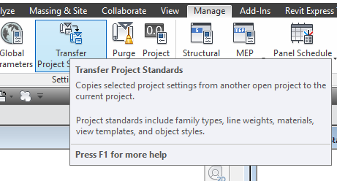

Figure 2.3‑1 Transfer Project Standards

## Central Files and Local Files

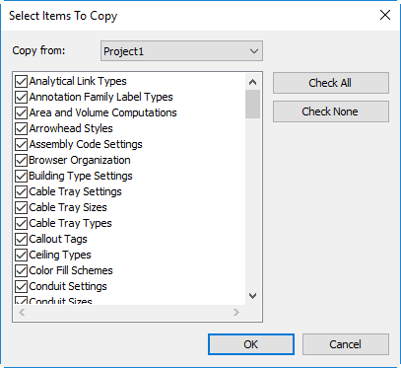

Figure 2.3‑2 Select Items

If multiple users will be working in the project, enable worksharing as part of the Revit file thru the creation of a central files.

### Central Files

Central files enable the ability to work in teams. The central file assigns ownership for all the elements in the building model as they are created and edited and acts as the distribution point for the project team. All members of the project team will use a local file to work from and then synchronize their work to the central file.

Worksharing starts with the creation of a central file. The central file assigns ownership for all the elements in the building model as they are created and edited and acts as the distribution point for the Project Team. All members of the Project Team will use a local file to work from and then synchronize their work to the central file.

### Local Files

Revit automatically creates and names a local file when opening a project central file and saves it to the user’s computer. Delete the local file at the end of each work day and create new one the next work day to maintain a well-functioning central file.

## Coordinate System Alignment ☑

The Airport employs a local coordinate system, SFO-B. Models and drawings submitted to the Airport shall reference the SFO-B coordinate system (x, y, and z coordinates). For more information and instructions on setting up the coordinate system in Revit, see the SFO BIM Guide – Appendix D.

## Container Concepts

A container file is a read-only Revit project used as a centralized repository of Revit System Families (i.e. Annotations, Partitions, Stairs and Railings). It is accessible to all users in a common shared server location. Each container file has dedicated views displaying an arrayed distribution of the standard content.

To access the content in container files, open the container file, select in the needed content and copy/paste them into the project.

A container file is editable only by the SFO Revit Standard Working Group to facilitate the uniform creation, maintenance and distribution of content.

Container files are also used to standardize system families. For system families and other settings, use the Transfer Project Standards tool to transfer information into the project file.

### Master Detail Containers

The Detail Container files are a collection of Revit drafting views with standard details that serve as starting points for project teams as they document their designs. The main purpose of this resource is to reduce the effort required to produce construction documentation while increasing the level of quality and knowledge about common building systems.

#### Using Detail Containers

In Revit: From the Insert tab, click on Insert from File > Insert Views from File:

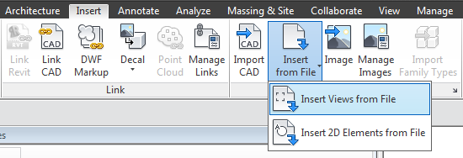

Figure 2.6‑1 Insert Views from Container Files

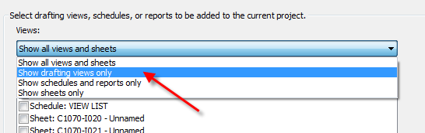

Figure 2.6‑2 Show Drafting Views Only

Select one of the container files. Navigate to the appropriate detail container file. When the Insert Views dialog box appears, the default setting is to show all views and sheets that can be inserted:

“Views” list and change it to “Show Drafting Views Only”.

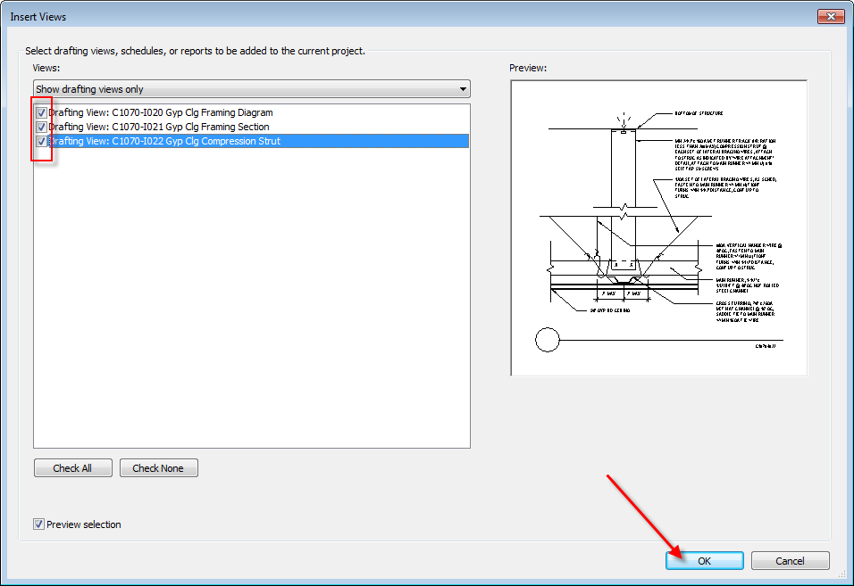

Figure 2.6‑3 Click OK

Select the drafting views you'd like to insert and then click “OK”:

## Model Maintenance

The adoption of a strategy for model management is critical for an efficient BIM workflow. Effective management is required to ensure that the model data remains coordinated, well-structured, and efficient.

Refer to the SFO Model Verification Standard in the appendix for more details.

## Archiving and Upgrading Requirements

Archiving a set of models is a requirement at the time of issuance of a milestone deliverable.

### Archive the Models

Create backup copies of the central models before beginning the upgrade process. Include a copy of all the linked files.

### Manually Upgrade File-based Workshared Project

Upgrading files to the latest release of Revit is a task required for projects with schedules that span multiple years, or an activity required for archived files needed as part of a new scope of work. Upgrading files is not a single-handed task but requires the approval of both the Design Team and the Airport project management

Upgrading steps:

* Schedule the Upgrade and Notify Stakeholders  
  Notify all the team members about the date and time of the upgrade and ask all team members to synchronize their local files, relinquish ownership of all elements and close local files by the time of the scheduled upgrade. The central file will be unavailable to the users during the upgrade process.
* Confirm the Revit version and build number
* Revit files cannot be saved to earlier versions. It is required that all team members work in the same Revit version and build. The version and build of Revit used in the project needs to be documented in the BIM Execution Plan.  
  Project Revit Coordinators may upgrade the project files to a newer Revit version to take advantage of new features and to stay up to date with software changes when the project spans multiple years. Upgrading a model is a planned activity that needs to be coordinated with every team member and should be approved and scheduled by the project manager.  
  Contractors and consultants must notify the Airport prior to implementing new software upgrades to verify that the Airport can accept the upgraded deliverables.
* Delete or Archive local files  
  Advise all users to archive or delete all the local project files and folders stored on their local workstation.
* Unload linked files  
  Most projects are a collection of cross-linked multidisciplinary files. To avoid the temporary upgrade of linked file(s), open each model and unload each linked file prior to upgrading. Do not remove the links as this may compromise the View Template overrides and other graphic settings.
* Start upgrading the linked files first. Unless otherwise agreed, each discipline is responsible for their own file upgrade. Request upgraded versions of the contractors’ and consultants’ files and replace them on the project server.
* Launch a session of the intended version of Revit.
* Open the central file with “Audit” and “Detach from Central” checkboxes enabled.
* Detach and Preserve the worksets.
* Save the file as a new central file at the same network location. Check the following Save As options: Change the Maximum Number of backups to 10, Compact the File, Change the Thumbnail Preview to the Start View drafting view, and change the Open workset default to ‘Specify’. (See Figure below)

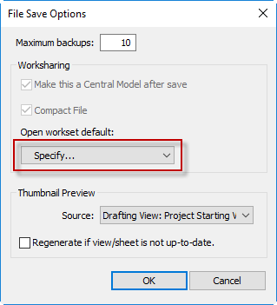

Figure 2.8‑1 Save Options

* Relinquish Ownership of all elements, save the file and close the central file.
* Reload the links.
* Once both the host and its linked files are upgraded, use the “Reload” button load the upgraded linked files.

1. Model Organization - Project Setup

## Views

### View Creation

All view names start with the View Series parameter, which matches the Sheet Series parameter in which the view will be placed, View Type code and two as-needed designators. Refer to Appendix View Naming Guidelines for naming conventions.

### MEP Views and Analytical Views

Revit can utilize the mechanical element and system properties to visualize different categories. Useful design information e.g. duct pressure drop, duct velocity, pipe flow, pipe fixture units, pipe friction factor, pipe pressure drop, and pipe slope can be used among a range of other categories. The system color scheme is set up to apply colors to different values or ranges of values for each category to visualize inefficient or non-compliant aspects in the MEP design.

## Worksets

Worksets are a collection of similar building elements grouped into manageable sets to support team members working in a single model. Worksets need to be defined considering the project’s scope, size, and the number of team members. The project Revit Coordinators document the worksets in the project’s BIM Execution Plan. Team members may create additional worksets for the project but should always consult with their discipline Revit Coordinator to limit the number of worksets in a project. Worksets created by a user should be made Non-Editable to eliminate the need for constantly giving permission for other team members to edit objects. User-created worksets should be saved to the central file with the “User-created Worksets” box checked to ensure that the worksets will be available for other team members to use if needed.

When worksharing is enabled, Revit creates default worksets and assigns project elements to these worksets. Existing levels, grids and reference planes are moved automatically to the Shared Levels and Grids workset. Model elements are automatically assigned to a default workset called Workset1.

Create additional custom worksets to allocate elements into loadable slices of geometry, and make sure to reassign elements to the appropriate one. Avoid using Workset1 for any purpose, and do not rename it. It is generally understood that Workset1 is a system workset that should not be modified.

The purpose of worksets is to unload from the temporary memory segments of the model that are not critical for the immediate task of the modeler. Except in rare circumstances, Worksets are not to be used to control the permanent visibility of elements in views.

You can decide to display or not the contents of a workset in specific views. The workset dialog box provides a column of checkboxes that controls the display of workset in different views.

As the model progresses, always check that elements are placed in the corresponding workset. Every modeler is responsible for keeping elements in the appropriate workset. For maintenance and troubleshooting, create a dedicated 3D view for each workset.

Another method to review element workset assignment is to use the Worksharing Display Settings, which applies a temporary color override to visually distinguish workshared elements.

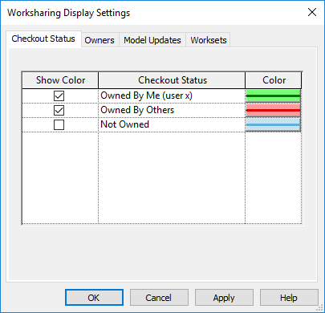

Figure 3.2‑1 Worksharing Display Settings

Revit offers several options when opening a Revit file with worksets (e.g. opening “all” worksets, “specify” user selected worksets, ‘last viewed’ to open worksets that were open during the last session, and ‘editable’ to open all worksets that are editable). Always use the “Specify” option to open only the worksets that you intend to work on at that time.

### Worksets for Scoped Work

Worksets can be used to segregate scope of work associated with deliverable packages. In complex projects, custom modifiers can be added at the end of the workset name.

Examples:

Core & Shell: Architectural components of the building core and exterior enclosure

Core-Sector A: Architectural components of the building core in Sector A

Equipment: Medical or lab equipment

FF&E: Furniture and furniture systems

Signage: Signs

Interiors: Interior walls and doors

Structure: Structural slabs, columns and beams

Site: Landscape and Site Model

Entourage: RCP families for rendering purposes

Shared Origin: Family aligned with the shared coordinate system

### Worksets for Linked Files ☑

Assign a workset for each linked file. AutoCAD drawings that are used as references, either by current view or an entire model, are placed in specific worksets. Linked Revit models must be separated into their own corresponding worksets.

Examples:

Link - AutoCAD: DWG references

Link - <Discipline>: Workset for all linked models for a specific discipline

### Worksets for Disciplines

Recommended worksets for disciplines:

Structural

Mechanical

Electrical

## Links

Linking enables additional geometry to be referenced into a model. This may be either sections of a model that are too big to manage in a single file, or geometry from another discipline or external consultants. Linked files are also used to separate buildings on site, split the scope of work of different disciplines and coordinate the work between consultants.

### Single Discipline Model Linking ☑

To maintain a manageable model file size, the scope of a single discipline may be split into multiple files and then linked back together. The number of models and the process of linking them needs to be determined by the Design Team BIM lead and defined in the project BIM Execution Plan.

Keep in mind best practices:

* Consider the user’s task allocation when splitting the model to minimize the need for users to switch between models.
* Place a monument family at the location of the Airport shared coordinate systems. This will provide a visual check to ensure all models align upon linking. Refer to the SFO Coordinate System Alignment Standard for an explanation of the Airport shared coordinate system.

### Multidiscipline Model Linking ☑

The Design Team disciplines typically build their own model(s) according to their contracted scope of work. Each discipline can link another discipline’s model for reference. Files used for cross-linking purposes are exchanged for reference work only. Do not, under any circumstances, edit the models provided by other disciplines.

Keep in mind best practices for the following:

* Prior to any model exchange, distribute and/or request the appropriate Data Transfer Agreement to describe the legal approved use of the project BIM data.
* Each discipline should respect the documented strategy for coordinate system alignment of the project BIM Execution Plan, and no deviation should occur without the approval of the project Revit coordinator.
* Certain modeled categories may have a varied degree of ownership thru the design cycle and should be documented in detail in the project BIM Execution Plan. For example, Floors can be created by the architectural team at SD and adopted by the structural team at a different stage.

### Linking Guidelines ☑

Before linking another a file, create a unique workset for the link. Then assign the link to the appropriate workset.

* Reference links from the link management menu should be set to “Overlay”.

### Linking CAD Files ☑

Any required CAD reference files are to be linked into the Revit model. Do not import CAD files because they bring foreign style definitions and generate file corruption.

Keep in mind best practices while working with DWG files:

* DWG files should be audited and purged before linking.
* Minimize the number of DWG links. Link DWG files instead of importing them.
* Link DWG: file can be updated in the original software (i.e. AutoCAD) and reloaded, like an external reference.
* Imported DWG: File remains as is. Any changes in the DWG file in the original software (i.e. AutoCAD) will not be reflected or reloaded unless deleted and linked again. Don’t explode DWG files.
* Delete hatches in DWG files if possible. Linking to DWG files with hatches will result in slow model performance.
* Remove all unnecessary linework, linetypes, layers and elements.
* DWG details should be redrawn in Revit. In many instances, line type issues and printing problems will take longer to resolve than to redraw the information in Revit.

### Importing CAD ☑

When importing a CAD files is unavoidable, leave the imported instance as a view specific, unexploded entity.

#### Line Weight Mapping of DWG import

When the DWG Line Weights are set to “Default” in the AutoCAD layer settings, the Line Weights in Revit will be assigned automatically according to a color layer mapping definition.

When the DWG Line Weights are set to a specified thickness in the AutoCAD layer settings, the Line Weights in Revit will be imported according to that thickness and the layer map text file will be ignored.

## Levels and Grids

Levels and Grids are workplanes defining the skeleton of a project.

### Levels ☑

Levels define the vertical height of a building story. Name the levels according to the SFO Building Level and Space Numbering Guidelines. All levels should be assigned to the “Shared Levels and Grids” workset.

The SFO Revit template includes single placeholder level. Rename and resize as need. When creating new levels, enable the ability to create the corresponding floor plans. See the ‘Views’ section for more information on how to appropriately create plan views.

### Grids ☑

Grids define the location of structural elements or building core assemblies. Assign all grids to the “Shared Levels and Grids” workset.

Grid naming conventions should be discussed by the project team and documented as part of the project BIM Execution Plan.

## Copy Monitor

The project team should coordinate the “Copy/Monitor” process with the project’s Revit Coordinators. Use the Copy/Monitor tool to monitor changes to elements across multiple disciplines and perform coordination reviews to identify potential issues.

### Copy/Monitoring Standards

Use Copy/Monitoring to track changes on linked grids and levels

Do not use C/M to track changes on slabs, walls and columns and MEP fixtures. Refer to Section “Ceiling Plan for Lighting and HVAC Diffuser Layout” for additional information on MEP ceiling coordination.

### Copy/Monitoring Best Practices

* Do not change the name of the linked Revit files when using copy/monitoring
* 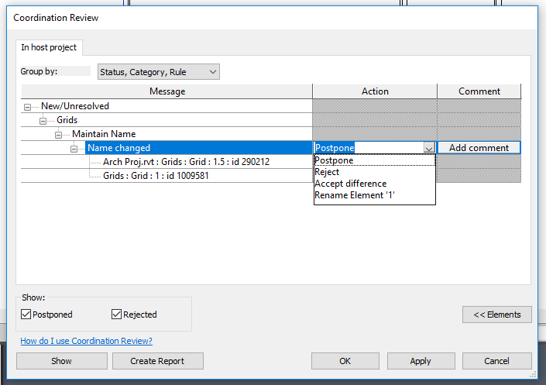To improve design coordination, run the Coordination Review tool to display a list of warnings about monitored grids and levels that have moved or changed. Teams can periodically review this list and specify an action (such as reject the change or modify the design).

Figure 3.5‑1 Coordination Review

* When a copy/monitored element is deleted from the source file, the warning cannot be resolved until the copied element is re-associated with a new object. To fix this, the copied element needs to be re-associated with a new linked family, followed by a break (stop) of the monitoring relationship.

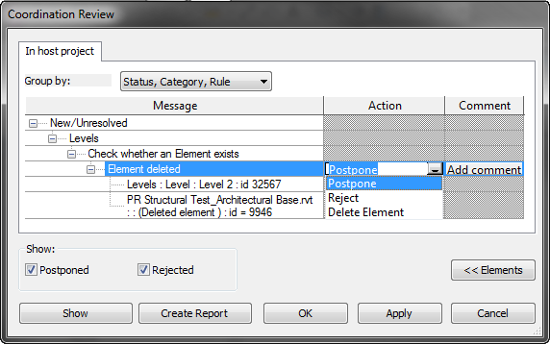

Figure 3.5‑2 Postpone Action

## Phases

Phasing distinguishes time periods within the life of the project. The Revit template provides default phases, Existing and New Construction. Complex projects may require additional phases. Document the need of additional phases in the project BIM Execution Plan and coordinate accordingly with all stakeholders.

Do not assign MEP components to a demo status as this breaks the integrity of the systems and disables the load calculation and flow analysis. To represent demolished MEP systems, assign the MEP objects to a dedicated workset (e.g. MEP-Demo) and apply a View Filter override to represent them in hidden lines.

1. Browser Organization

Use the Browser Organization tool to group and sort views, sheets, and schedules/quantities in the way that best supports your work. You can specify multiple levels of grouping. Within groups, items are sorted in ascending or descending order of a selected property.

## Views (SFO View Browser) ☑

The SFO Revit template files have a built in SFO View Browser to sort views and sheets in a project. The “View Series” and “View Type” Project Parameters are used to sort views, “Sheet Series” and “Sheet Type” serve to sort sheets.

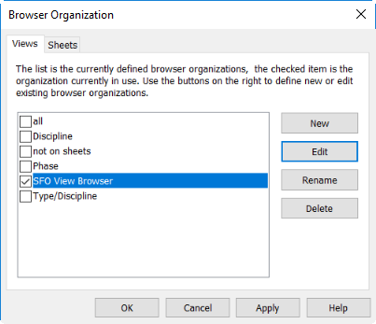

Figure 4.1‑1 SFO View Browser

### View Naming

Basic information about the type of a view (e.g. plan, section, elevation, or 3D) is automatically generated by Revit. Additional details to describe the view needs to be added manually.

Refer to the “SFO View Naming Guidelines” in the appendix for more details.

### View Series and View Type

Fill in the “View Series” and “View Type” parameters at view creation. This habit will help maintain an organized project browser.

### Starting View

A 2D starting view helps the opening of large models, as 3D views typically require longer to regenerate. A starting view should be employed on all projects to identify the Contract Number, Project Name, Discipline, BIM Manager or Revit Coordinator, File Creation Date, Transferred Date, and key project Team Leads. The SFO Starting View can be found in the SFO Revit Template files. When exchanging the model to consultants, edit the Transferred Date label.

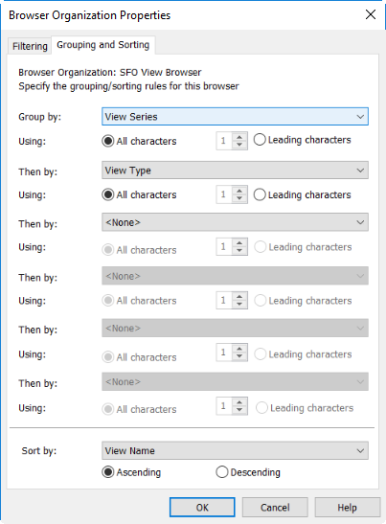

Figure 4.1‑2 SFO View Organization Group/Sorting Rules

### Working Views

Working views are intended to support the modeling and design documentation process. The Revit Coordinator should delete working views that are not regularly used to maintain model performance and reduce overall file size.

Best Practice:

* Each user will identify non-sheet, working views with their initials.

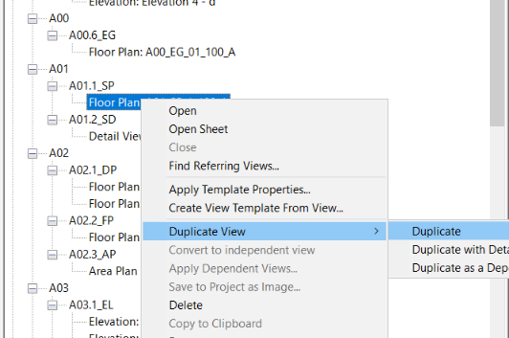

Figure 4.1‑3 Create Working Views by Duplicating

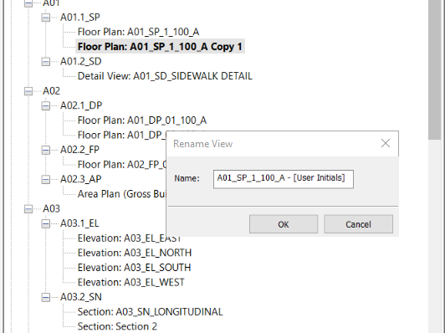

Figure 4.1‑4 Include User’s initials in Working View’s Name

## Sheets (SFO Project Browser)

Fill in the ‘Sheet Series’ and ‘Sheet Type’ parameters when creating new sheets. Placing new views onto sheets immediately after the view has been created aides in sorting and deleting any unused views in the Project Browser.

Sort sheets in the project browser using the “SFO Sheet Browser” definition. This custom organization uses the shared parameters “Sheet Series” and “Sheet Type” to group the sheets according to the sheet series they belong to and the sheet type abbreviation. Refer to the SFO Sheet Numbering standards for information on these parameter values.

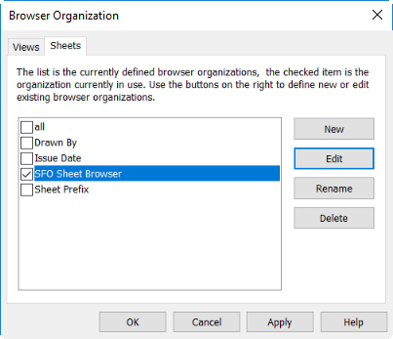

Figure 4.2‑1 SFO Custom Sheet Organization Definition

1. Graphic Settings

Graphic Standards are important in communicating design intent through drawings. It is important to follow these standards to maintain consistent project documents for all design and construction projects at the Airport.

## Titleblocks and Sheets ☑

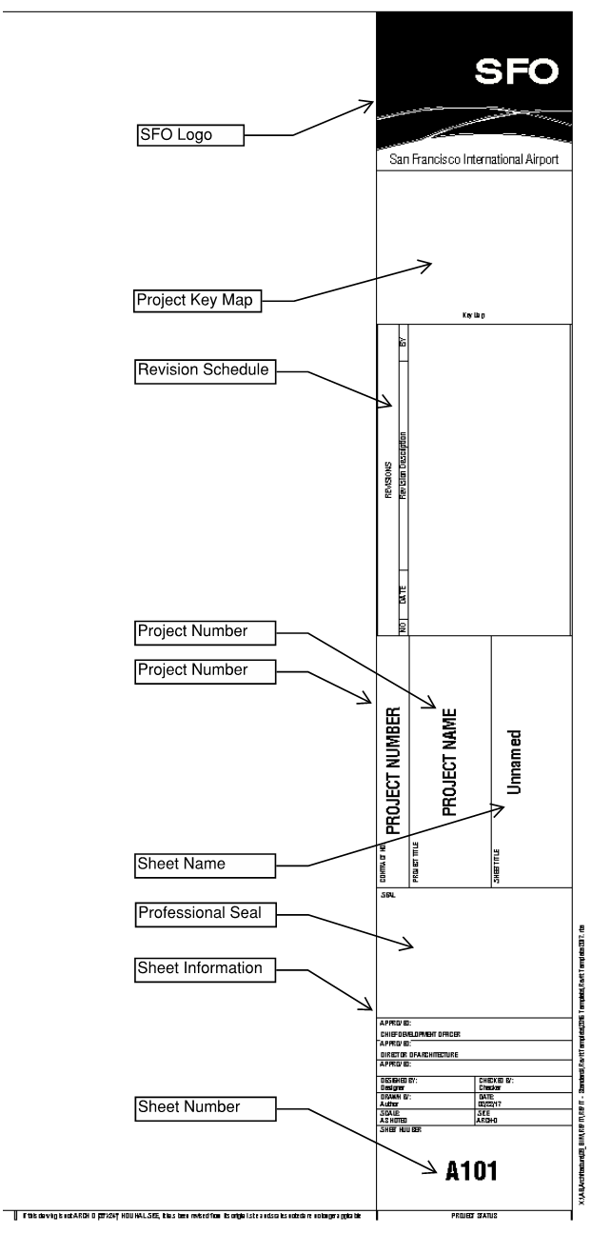The SFO title block is a parametric family that displays the logo, project information, issue dates, revision information and professional seals on each sheet. The Project Name, Number, Address parameters can all be accessed under the “Manage” tab, through “Project Information” and should be filled out for every project. The title block also has on/off parameters for professional seals, a grid and horizontal and vertical note blocks to help standardize sheet layouts.

Figure 5.1‑1 SFO Title Block

## View Templates and View Filters

A View Template consists of graphic properties that define the look of view types such as enlarged plans, overall plans, varying scales for sections, etc. Using a View Template allows for consistent graphic display of elements in multiple views.

The following items can be defined as a group of settings for a View Template: view scale, discipline, detail level, visibility settings, filters for work set controls, model display settings, visibility graphics overrides for models, visibility graphics overrides for annotation, model graphics style, advanced model graphics, far clipping, view underlay control, view range, project orientation, phase filter, color schemes and depth clipping.

The SFO template files provide pre-set View Templates as a standard set of references updated on a regular basis to support uniform project documentation. The project team should not modify the original pre-set templates. Instead of modifying the original templates, the project team should create additional View Templates to manage project documents as needed.

For clarity to a user, remove unused View Templates not applied to any view.

View Filters provide and additional method to control graphic display and visibility of elements based on attribute values. View Filters can use worksets to control graphic display of elements. When View Filters are used to control worksets, View Filters control the graphic display throughout the entire Revit project. View Templates that use View Filters provide one convenient place for these settings versus modifying individual views throughout an entire project.

### Color Codes for Mechanical Systems ☑

Mechanical duct and pipe systems are independent of the duct and piping elements that are placed in a project to show the routing and connections between air terminals, mechanical equipment, or plumbing fixtures. Once air terminals and mechanical equipment are placed in a project, supply, return, exhaust and other air systems can be created to connect the components of the duct system. Once plumbing fixtures are placed in a project, domestic hot water, domestic cold water, sanitary and other piping systems can be created to connect the components of the plumbing system.

SFO uses eight duct system types and fifty-six piping system types customized to handle specific types of components and systems found at the airport. A list of duct and pipe system types can be found in the SFO Element Attribute Dictionary.

Setting up mechanical system View Filters and applying different color overrides is a two-step process. The first step is to establish the filter criteria for the different mechanical duct and piping systems. An example filter for a ‘Supply Air’ mechanical duct system is shown below. The filter is set up to look for duct-based categories that have a system type of ‘Supply Air’.

The second step in using View Filters to color mechanical systems is to apply a visibility override to the filtered elements. Once a filter has been created in the first step of the process, it can then be selected in the filter tab of a View Template. A color override can be applied to the line style for each mechanical system filter. Once the View Template is applied to a view, the ductwork or piping will be colored according to the color overrides for each filter.

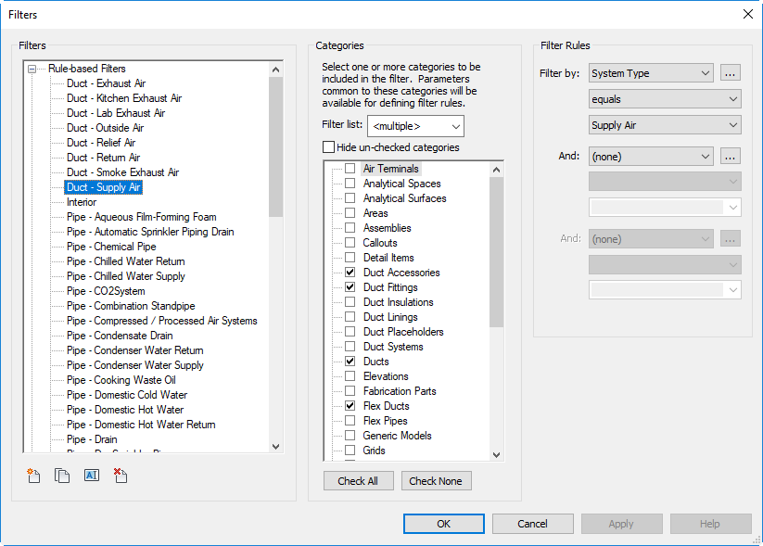

Figure 5.2‑1 Mechanical System Colors - View Filter Setup

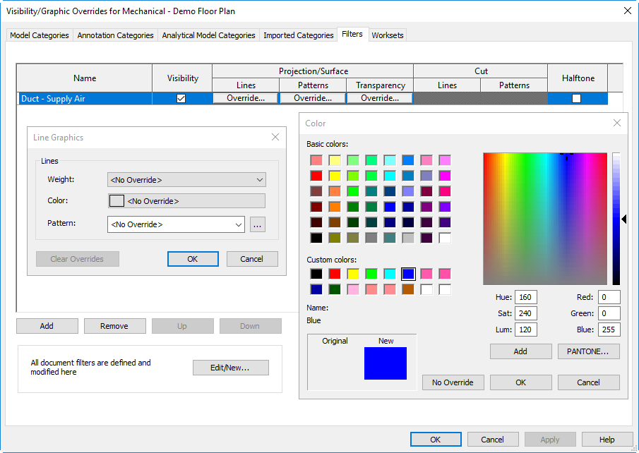

Figure 5.2‑2 Visibility/Graphic Overrides

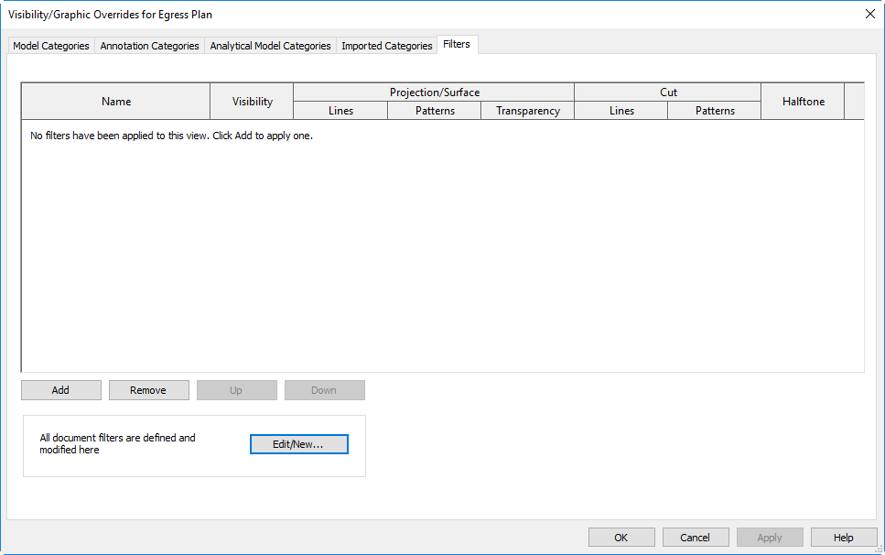

Figure 5.2‑3 Mechanical System Colors – View Filter Visibility Override

The View Filter process only applies mechanical system colors to a specific view and does not affect other discipline models or other views within the mechanical model. Applying mechanical system View Filters to specific working views or sheet views should be done as part of a View Template. Applying filters to individual sheets is a time-consuming process that is not necessary when using View Templates to establish visibility settings.

### Color Schemes

Use color schemes to graphically illustrate categories of spaces. You can apply fill patterns to Rooms, Areas, and Spaces/Zones. Create a color scheme by selecting the appropriate category and specifying the Color Scheme definitions.

### Area Plans

Area plans are used to verify that assigned areas on the floor plans match the required building program. They are also used by SFO’s Aviation Management and Revenue Development and Management departments to establish, track and manage leasehold areas. Use area boundary lines as needed to demarcate areas not readily defined by walls such as holdroom areas, concession seating areas, queuing and circulation spaces from each other. Plumbing chases, mechanical shafts, gate houses and boarding bridge limits should also be clearly identified on the area plan.

### Departments

Departments should be used to identify the type of leasable space represented on the floor plans. At a minimum, departments would include Airline, Food & Beverage, Retail, Support and Government. Confirm proposed department identification with Aviation Management.

The use of color is an integral component in the creation of a memorable brand. The consistent use of these elements is crucial to building clear communications and brand awareness. SFO Color Fill Legends come in four palettes. Additional palettes may be created when the SFO Brand colors do not provide a broad enough range of colors to meet the project needs such as a terminal modernization program. Confirm color schemes to be used in the BIM Execution Plan.

### Object Styles

The Object Styles dialog box specifies the project-level settings of Line Weight, line color, line patters and default materials for the different categories and subcategories of model elements, annotations and imported objects in a project. Projects created with the SFO template will receive the SFO preferred object style definitions. The published appearance of modelled components shall be consistent across models, hence do not modify a project Object Styles unless approved by project BIM coordinator.

#### Line Weights

The Line Weights settings control the line representations of geometry on-screen and on the published outputs. The Line Weight assigned to model elements are scale specific while those associated with annotations are fixed. Revit contains 16 model Line Weights, and each can be given a plotted thickness across a range of drawings scales.

#### Line Styles

Line Styles are defined in the SFO templates as project settings. System line styles used by certain Revit subcategories cannot be deleted or purged and remain with the out-of-box name. Custom line styles are defined in the SFO template. Any additional line styles shall be created by the BIM coordinator and named according to the following naming conventions.

[Line Weight]-[Line Style]

Line Weight: Line Weight number (1 - 16)  
Line Style: Line Style Name

Examples:

1-Solid

3-Solid

5-Hidden

#### Line Patterns

Line Patterns are defined in the SFO templates as project settings. Any additional Line Styles shall be created by the BIM coordinator and name according to the following naming conventions.

[Description] [Size]

Description: Pattern Description, i.e. Dash Dot Dot  
Line Style: Size of the largest dash size (inches)

Examples:

Dash 1/4

Dash Dot Dot 1/8

Hidden 1/8

#### SFO Branding and Color Palettes ☑

SFO’s color palette features modern, bold colors that reflect the airport’s brand personality. This palette should be used for any presentation documents prepared for a project. This can include architectural area plans, font color or line work, etc. These palettes are built into the SFO Revit Template, found in Color Schemes.

Use the following color specifications for the entire SFO color palette. Do not modify the colors and avoid approximating and visually matching the colors.

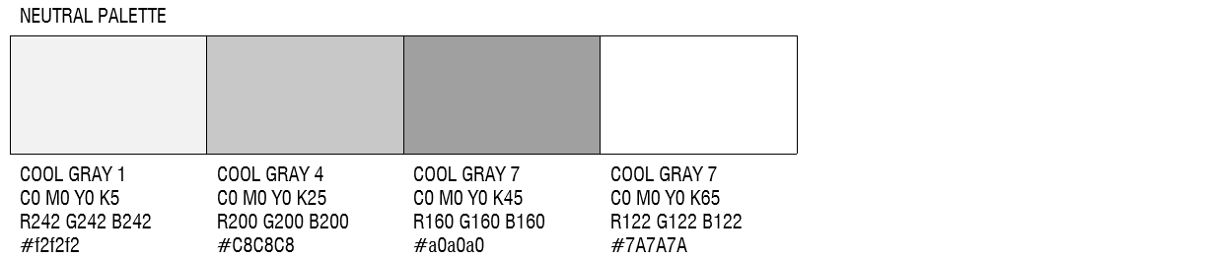

Figure 5.2‑4 Neutral Palette

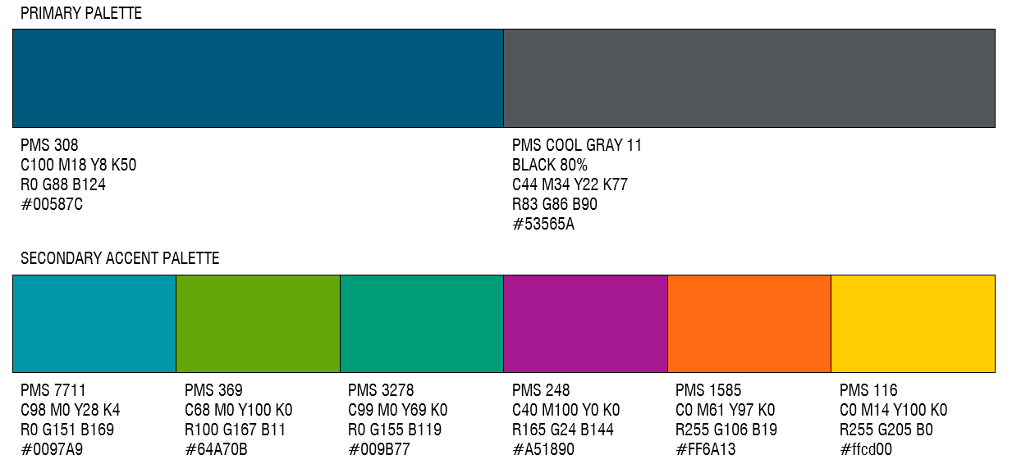

Figure 5.2‑5 Primary Palette

The neutral color palette was selected to complement the primary and secondary palettes.

1. Model Content

## Families

The power of BIM and Revit lies in the ability to create 3-dimensional representations of building systems, furnishings, fixtures and equipment while accurately maintaining the key information stored within the elements. Following best practices for content creation will ensure the consistency, performance and accurate representation of product data.

Content should be created with the following considerations:

* Design Intent
  + How a family will be used in a project
  + Appropriate level of detail
  + Adequate number of types created
  + Flexible use of parameters
  + Accuracy - Complete, consistent presentation of product data
* Standards - Naming Conventions, Graphic Guidelines, Parameter Usage
* Performance - Content designed to minimize the performance impact on a project.
* Testing - Thorough testing of the family parameters and types independently and within the project environment.

### Family Creation Guidelines

For the best practices and requirements about creating and adopting families, see the Appendix “SFO Family Creations Guidelines”

### Family Naming ☑

The family naming follows the guidelines established in the SFO Element Attribute Dictionary.

### Coordination with Families

All types of families can be used for internal coordination or coordination with other trades. The parameters stored within a family can convey design information required by other trades, flag the element for review or coordination, scheduled data, and many other possibilities. The graphical representation of the family is also used for 3D design coordination, clearance requirements, routing coordination, etc.

Coordination can be accomplished through coordination schedules, which is discussed later in the SFO Revit Standard and through coordination views. Coordination views highlight specific elements within working views that require coordination with other disciplines. For example, a fan coil unit is designed by the mechanical designer but requires a condensate connection from the plumbing designer. The SFO shared parameters are filtered to highlight the fan coil unit that requires a condensate drain connection by the plumbing designer.

### Connectors

A primary difference between MEP components and components for architecture or structural engineering is the concept of connectors.

For system engineers, all MEP components require connectors to behave intelligently. Components created without connectors cannot be integrated into a system. Connectors are logical entities that allow load calculations within a project. Revit maintains information about loads associated with the spaces in a project. As devices and equipment are placed in spaces, Revit tracks the loads based on load type: HVAC, Lighting, Power, or Other. Connectors communicate pipe size and flow, duct size and flow, and circuit voltage, phase, and demand factor information between Revit elements.

SFO uses a custom list of MEP systems specific to the airport campus and each connector type. A description of each SFO MEP system can be found in the SFO Element Attribute Dictionary.

MEP Connectors in Revit Families

The connector type determines the systems it can interact with and how it interacts with other system components. Selecting the correct discipline is critical to the content working correctly. After the connector selection is made, it cannot be changed without first deleting the connector and adding it again with the correct discipline. When connectors are added to a family, the following disciplines can be specified:

* Duct connectors: associated with ductwork, duct fittings, and other elements that are part of the air distribution systems.
* Electrical connectors: used for any type of electrical connections, including power, telephone, alarm systems, and others.
* Pipe connectors: used for piping, pipe fittings, and other components that are meant for transmitting fluids.
* Cable tray connectors: used for cable tray, cable tray fittings, and other components that are meant for wiring related to communications.
* Conduit connectors: used for conduit, conduit fittings, and other components that are meant for wiring related to all Electrical systems.

Properly specifying connector size, flow, pressure, and power values in Revit families is critical for accurate MEP system calculations in Revit projects. Mechanical and Electrical family connector element data should be mapped to an appropriate SFO shared parameter where available to maintain interoperability with MEP schedules and Coordination Schedules.

MEP Connectors in Revit Projects

Once a family containing MEP connectors is loaded into a Revit project, MEP systems can be created. Selecting a family or element with duct, electrical, pipe, cable tray, or conduit connector(s) allows for the creation of a new MEP system or modification to an existing MEP system. The specific tools used to create MEP systems depend on the component and the types of connectors in the family. Multiple connectors of the same or various types can be used in a single family. Connectors should be used to accurately represent the size, quantity, and location of MEP equipment connections required and consistent with the Model Element Table in the BIM execution plan.

For connectors to properly pass information throughout a mechanical system or electrical circuit, it is critical for all elements to be connected or capped. If any connector element in the system is disconnected and there is an open duct, pipe, or circuit at the end of a branch, the MEP system flow or power cannot be accurately calculated. Duct and piping systems may show no flow where there are open branches. Power systems will not include equipment disconnected from the electrical system and disconnected equipment will not show up in panel schedules. If data is not being passed throughout MEP systems, ensure all the ducts, pipes, or circuits are properly connected without any open ends.

Fully connected mechanical systems can utilize Revit analysis tools. Revit analysis tools include the system inspector and visibility color schemes, which are explained in more detail under the Mechanical System Analysis Section.

## Parameters

Parameters store and communicate information about elements in a Revit model. Parameters can be created for a project and for a specific element or a component category within a Revit project. There are four different types of parameters: Project, Family, Shared, and Global. Each type also has a parameter reference type, which depends on which type of discipline specific data is being configured.

### Parameter Creation Guidelines

See the SFO Element Attribute Dictionary for more information about data requirements for parameter creation and naming.

### Project Parameters

Project parameters are added to specific element categories, sheets, or views within a Revit project. Project parameters cannot be shared with other projects. Project parameters can be used in schedules, for sorting and filtering but cannot be used for tagging.

### Family Parameters

Family parameters are only contained within a Revit family and can be used to control variables or values of the family. Family parameters can also be used to control a parameter in a nested family by associating the parameter in the host family to the parameter in the nested family.

### Shared Parameters

Shared parameters are parameters stored in a specially formatted text file independent of any family file or Revit project. Shared parameters can be added to families or projects. Shared parameters can be used to create schedules, for sorting and filtering and for tagging.

### Global Parameters

Global parameters are specific to a single Revit project, but are not assigned to categories like project parameters. Global parameters can be simple values, values derived from equations, or values taken from other global parameters.

## Schedules and Coordination Schedules

Schedules and coordination schedules are Revit schedules created with SFO shared parameters to allow for bidirectional communication between the scheduled values and the shared parameters contained within the equipment families.

### Schedules ☑

Schedules offer two-way communication between the shared parameters contained in the family and the same shared parameters displayed in the schedule. Revit schedules that reference shared parameters display the shared parameter value contained in the Revit family file. Changing to the shared parameter value in the schedule view or in the family properties window has the same effect on the shared parameter value. Schedules can also reference shared parameters stored in linked Revit models. Shared parameter values from linked models are only displayed and cannot be modified. Referencing shared parameters from linked models is best used for coordination with other trades either via schedules or through plan View Filters.

When adding a field to a new schedule or existing schedule, the ‘Add Parameter’ button is used, and a shared parameter is added from the SFO shared parameter file to the schedule. The shared parameter file is displayed, filtered, sorted and formatted in the schedule the same as a project or family parameter. Shared parameters can be added to both single and multi-category schedules.

Since the Schedules reference the same SFO shared parameters used in the Revit family files and the same SFO shared parameters used in different projects, the Schedules can also be re-used across multiple projects. Schedules are stored in a Revit container file. This container file is a blank project that includes pre-defined Revit schedules that can be copied between the Revit container file and a new project (See Section 2.6). Copy and paste the schedule that’s been placed on a sheet in the container file onto the target sheet in the new project.

The Schedules in the container file are set up for different types of equipment The shared parameters associated with different equipment types are referenced in the schedule fields and the filters are set up to filter for specific equipment types. The schedules will appear blank in the container file, but as soon as they are loaded into a Revit project with Revit families using the SFO shared parameters, the schedules will be populated with all the shared parameter data stored in the Revit families. If Schedules do not automatically populate with equipment data, check the schedule filter is setup correctly for the equipment type to be scheduled.

### Coordination Schedules

Coordination schedules are a variation of the Schedules described above. Instead of using shared parameters to populate equipment schedules within a single discipline, the coordination schedules are used to coordinate between different disciplines. Coordination schedules can be used to pass power requirements to the electrical engineer, water or sewer connection requirements to the plumbing engineer, or heat dissipation information to the mechanical engineer to name a few examples.

The foundation of the coordination schedules is the SFO Shared Parameters and more specifically the Connection parameters. The connection parameters are used to filter specific elements from linked models for coordination and then the specific MEP parameters can be used for coordination. For example, the SFO Electrical Connection parameter is used to filter a mechanical pump that requires an electrical power connection. The coordination schedule in the Electrical Revit model can filter for mechanical equipment in the Mechanical Revit model requiring electrical connection and the power requirements from the mechanical engineer can be transferred to the electrical engineer within the Revit environment through the SFO shared parameters. The mechanical engineer still needs to communicate with the electrical engineer when the power requirements are ready for coordination, but this information can be stored in Revit rather than transferred via PDF or paper cut sheets.

## Electrical Panel Schedules

Revit panel schedules display information about the branch panel, data panel (or switchboard), the circuits connected to each panel and their corresponding loads. Mechanical ductwork and piping analysis tools are discussed in the Analysis section of the SFO Revit Standards.

### Panel Schedule Overview ☑

The Panel Schedules command can be found on the Analyze tab of the ribbon. The SFO panel schedules are setup in the SFO Revit Template.

A panel schedule has 4 parts:  header,  circuit table,  loads summary, and  footer.

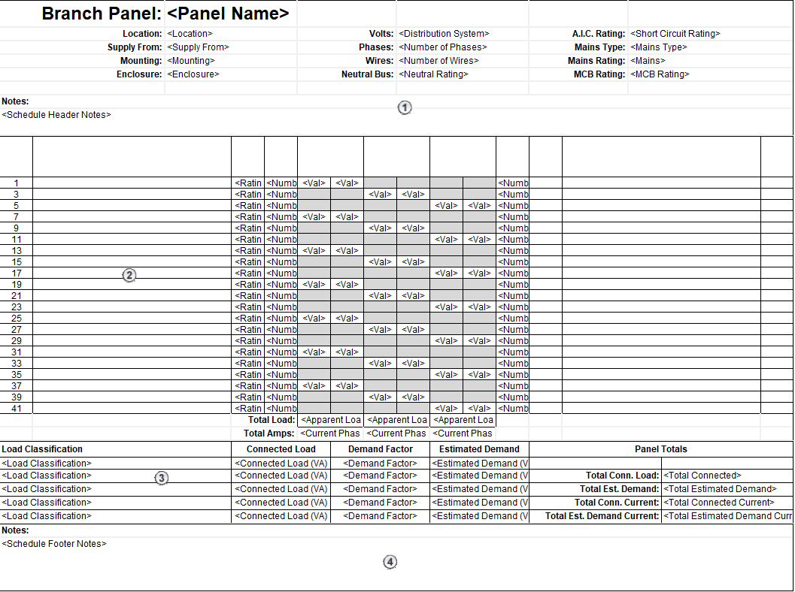

Figure 6.4‑1 Electrical Panel Schedule

### Creating Panel Schedules

Panel schedules are created to display information about the panel, the circuits connected to the panel and the load summary.

Before the panel schedules are setup, the voltage definitions and distribution systems need to be defined. The voltage definitions and distribution systems can be found by clicking the Electrical Settings button on the Manage tab of the ribbon in the Settings group under MEP Settings. The standard voltage definitions and distribution systems are setup in the SFO Electrical Revit Project Template, but any new or unique systems can be defined on a project by project basis.

Panel schedules can be created by selecting a panel or multiple panels of the same type, and then ‘Create Panel Schedule’ command on the Modify tab of the ribbon or through the Panel Schedules command on the Analyze tab of the ribbon.

The general process of customizing and creating Panel Schedules is outlined below. Steps 1 through 6 have been completed in the SFO Revit Electrical Template and only need to be modified where projects have unique requirements.

1. Establish and Define all Voltage Definitions.
2. Establish and Define all Distribution Systems.
3. Establish Load classifications.
4. Establish Demand Factors.
5. Assign Demand Factors to Load Classifications.
6. Format the Panel Schedule Templates.
7. Assign Load Classifications to Family Connectors. Refer to MEP Connectors section for more information.
8. Create Panel Schedules from Templates.
9. Circuit and Manage Loads on Panels.

It is best practice to create Panel Schedule Templates that allow for the resilience of the Panel Schedule based on fluctuating parameters. For example, an electrical panelboard family utilizes the parameter that determines the number of one-pole breakers as an Instance Parameter that can fluctuate throughout the course of the design. Having Panel Schedule Templates with the 'General Settings' - 'Size' - 'Number of slots shown' option set to 'Fixed to a constant value' is unfavorable because the template must be changed for this Panel Schedule instance. Changing templates too often can lead to data being lost if it is not stored in parameter values. Therefore, it is recommended to always create Panel Schedule Templates with the 'Number of slots shown' set to 'Variable based on maximum number of one-pole breakers'. Any fluctuation in quantity of available panel poles can be reflected in the schedule without modifying or changing the template.

### Managing Panel Schedules

Power circuits can only be connected to a compatible panel. The panel being selected for connection must have a slot available and must match the distribution system for the circuit being connected. To add a circuit to a panel, highlight a component in a circuit and edit the circuit. Select a panel from the Panel drop-down list to connect the circuit to a panel.

Panel Schedules are automatically populated based on the connected electrical equipment, devices, and fixtures. The Panel Schedule Template applied to a panelboard can be changed after it has been created, but any notes or data specific to the original template that is not stored in parameter fields will be lost after switching to a new Panel Schedule Template. When a panel schedule is displayed the circuits can be rearranged on the panel by moving them up, down, left, or right. The panel load can also be balanced across phases, spares or spaces can be assigned, and circuit names can be edited directly in the panel schedule.

As new projects bring new requirements, the Panel Schedule Templates should be updated, and new Panel Schedule Templates should be created to suit the new project needs. It is best practice to duplicate existing panel schedule templates and modify as needed to expedite the process rather than create a new template from scratch.

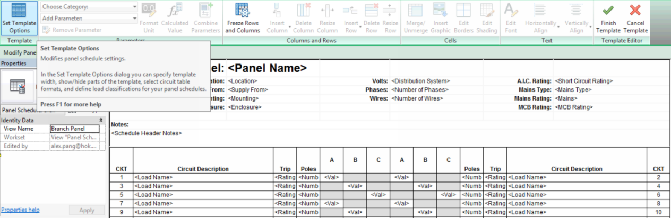

Figure 6.4‑2 Panel Schedule Template icon location

If a non-standard Panel Schedule is required, the Revit Coordinator should be notified. The panel schedule should be added on a project basis and the Panel Schedule should not be stored in the SFO Revit template file. It is useful to flag non-standard Panel Schedule(s) so they may be easily identified by other electrical team members.

## Modeling Requirements

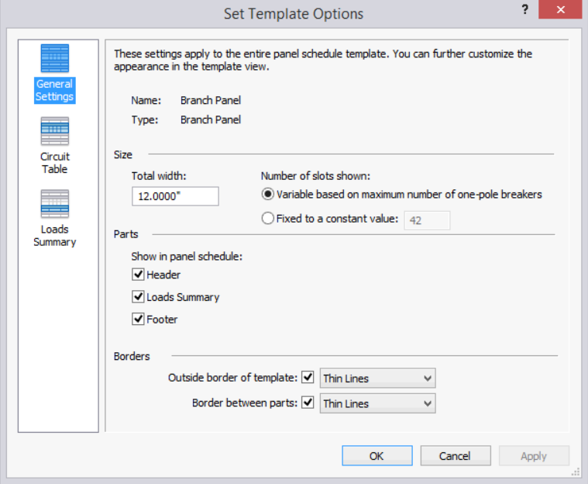

Figure 6.4‑3 Template Options

The purpose of this section is to define the minimum precision of the modeling efforts. During schematic design, modeled assemblies are expected to convey the Design Team product intent. As designs progress through development, all generic content shall be replaced with specific content dimensioned and assembled by the correct constituent elements.

Revit Model Precision:

All dimension strings generated through Revit must be live dimensions. Manual overrides are prohibited except when the override is descriptive (i.e. VERIFY, CLEAR). The following chart outlines the required minimum dimensional rounding settings.

|  |  |  |  |  |  |  |  |  |  |
| --- | --- | --- | --- | --- | --- | --- | --- | --- | --- |
| Length | | Area | | Volume | | Angles | | Slope | |
| Rounding | Units | Rounding | Units | Rounding | Units | Rounding | Units | Rounding | Units |
| 1/8” | Feet and Fractional Inches | 0 Decimal Places | Square Feet | 0 Decimal Places | Cubic Feet | 1 Decimal Place | Decimal Degrees | 1/4” | Rise/12” |

Table 1 Revit Model Precision

Any project-specific deviation of these precision standards needs to be documented in the BIM Execution Plan.

The following chart indicates what elements need to be modeled and to what level of precision organized by Uniformat section:

|  |  |
| --- | --- |
| UNIFORMAT SECTION | DESCRIPTION |
| B20 Exterior Vertical Enclosures  C10 Interior Construction | Although standard wall and ceiling individual framing members are not modeled, any atypical framing features required for tiered ceilings, soffits, curved walls, arched ceilings, etc. should be modeled to ensure there is enough available space for all the additional framing/bracing for these components. Walls are to be modeled to the correct height and extend to the inter-ceiling space as needed for coordination. |
| D20 Plumbing  D30 HVAC  D40 Fire Protection  D50 Electrical | All Equipment shall be modeled to show required clearances for maintenance, safety and operations. This 3D clearance envelope should be modeled so that it will appear in clash detection |
| D30 HVAC | All ducts and air handling equipment shall be modeled to the outside face dimension adding insulation as its own entity where applicable. |
| D20 Plumbing  D30 HVAC  D40 Fire Protection | All piping 3/4” or larger shall be modeled to the outside diameter of the pipe, adding insulation as its own entity where applicable. |
| D50 Electrical | Conduits 3/4” or larger and large groups of conduits 3/4” or less in a particular location shall be modeled to reflect the overall space requirements. |
| D60 Communications | For telecommunications systems, at a minimum, all cable tray, wire management hooks, conduit 3/4” or larger and communication racks and cabinets shall be modeled. Large groups of conduits 3/4” or less in a particular location shall be modeled to reflect the overall space requirements. |
| D70 Electronic Safety & Security | All components of the fire alarm system shall be modeled including all panels and devices with access zones and conduit 3/4” or larger. Large groups of conduits 3/4” or less in a particular location shall be modeled to reflect the overall space requirements. |

Table 2 Uniformat Sections

## Mechanical Systems Analysis

Mechanical systems, ductwork and piping, are at the core of the Revit mechanical analysis tools. Fully connected ductwork or piping systems, without open ends, can utilize the Revit System Inspector and the mechanical systems analysis visibility color schemes. The electrical systems analysis tools are discussed in the Electrical Panel Schedules section.

### System Inspector

The System Inspector is engaged by selecting a section of a mechanical system and then clicking System Inspector from the Modify tab on the Ribbon under the Duct/Pipe and the Analysis panel. Once the System Inspector is engaged, clicking the Inspect button on the System Inspector tab will show the air or water flow path in blue and the path with the highest pressure drop in red. Selecting a component in the mechanical system while the System Inspector is active will provide more detail about the selected section of the mechanical system. The System Inspector tool is useful to identify the highest pressure drop in a mechanical system and for a quick analysis of the individual system components.

### Analysis Visibility Override

Analysis visibility color schemes are applied to a specific view in Revit and selected attributes of mechanical system can be colored to identify different ranges in size, velocity, pressure loss, slope, or other system parameters. The visibility color scheme is a simple way to identify low or high velocity, high pressure drop, under or oversized sections, or varying slopes within a ductwork or piping system. Unlike the System Inspector, the analysis visibility color scheme is applied to a single working view and the color override is always applied to the view where the System Inspector is a temporary override. The analysis visibility overrides are most effectively applied through a dedicated View Template. The analysis views are activated through the View Template View Properties window and under System Color Schemes tab. The duct and pipe color schemes are set independently, and the analysis parameter is set for each duct or pipe scheme. Duct and pipe analysis visibility override View Templates are setup in the SFO MEP Revit Templates.

## Detailing Standards

### Creating Details

The Airport understands that not all information in a project will be captured via model elements. To achieve the benefits of BIM, the Airport expects the project team, via the BIM Execution Plan, to clearly identify the methodologies that will be used to maximize the usefulness of the BIM tools. Over-modeling (the creation of elements beyond the required level of documentation) and under-modeling (the creation of elements below the required level of detail) is to be avoided. See the SFO Element Attribute Dictionary for model data development and management criteria as well as the Model Progression Specification, and Common Attribute Sets.

Rule of Thumb:

If it needs to be coordinated, it is to be modeled to the appropriate level of detail required to help identify any conflicts.

Utilize detail components to supplement the graphic quality of model elements in 2D representations of construction components. Detail components are to supplement, not substitute model elements. Utilize the same level of care when using detail components, maintaining document accuracy and clarity as exercised for model components.

### Converting CAD Details

Project teams may find the need to convert CAD details into Revit Drafting Views. While there is not a foolproof method to do this, there are a couple of recommended methods.

#### Method 1 (Preferred): Link and Retrace

* Link a DWG temporarily into a Drafting View. Change the drafting view scale to match the DWG detail.
* Retrace geometry with standard Revit lines. Use the Pick Lines drafting line option to speed up the process. (See figure below.)
* Use standard Fill Regions when appropriate.
* Identify opportunities to use Detail Components: Avoid retracing geometry that can be a Revit detail component (i.e. to represent a screw, load the appropriate screw detail component from the general or discipline specific library, rather than tracing its lines).
* Rebuild text and dimensions with Revit Annotations and Dimension families. Follow SFO standard text and dimension.
* Once the DWG is retraced, remove the link. What is left is a detail made with native Revit objects.
* Purge unused. Save as the detail in the Project folder.

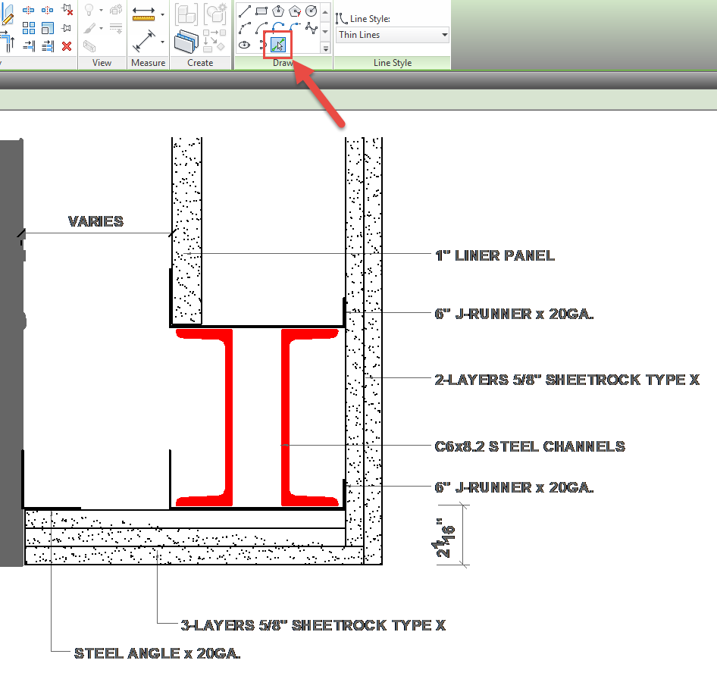

Figure 6.7‑1 Tracing DWG

#### Method 2: Explode in a Working File, Swap and Copy/Paste:

In very limited circumstances, we may convert a DWG into REVIT objects by swapping the line styles in a temporary working file.

* Create a new file using the SFO template.
* Import the DWG into a Drafting View. Change the drafting view scale to match the DWG detail.
* Partial explode the DWG in this working file. Never explode the DWG in the actual project because this compromise the integrity of the project text styles, pattern definitions, line patterns and line styles.
* Select all objects in the drafting view and use the Selection Filter to select lines by DWG layer name, and swap with the appropriate standard Line Styles.
* Rebuild DWG hatches with standard Revit Filled Regions
* Swap DWG imported text style with standard Revit Annotation families. Add the appropriate leader type and rebuild dimensions. This is unfortunately a manual task.
* Identify opportunities to use Detail Components: Avoid retracing geometry suited to be part of a Revit detail component.
* Once all the DWG geometry is swapped with Revit definitions, copy and paste the detail into a project drafting view.
* Purge unused. Save as the detail in the Project folder.

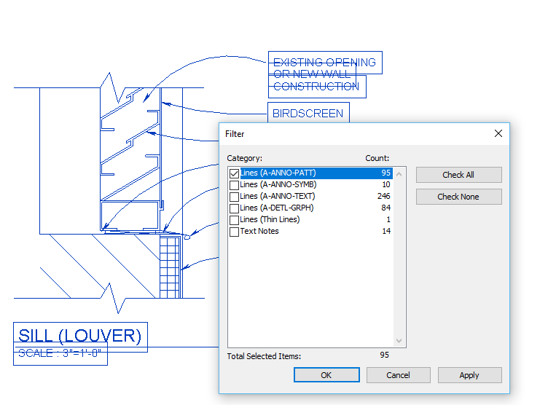

Figure 6.7‑2 Use the Filter Tool

1. Appendices

## Abbreviations and Acronyms

## Family Creation Guidelines

## View Naming Guidelines

## Change Request

1. Attachments

## Sheet Numbering Standard

## Coordinate System Setup

The development of the SFO Revit Standard is the result of a collaborative effort of the SFO Revit Standard Working Group. The information contained herein is based on our knowledge, experience, and hardware and software technologies at the time of the publication. We recognize the importance of continued Revit Standard development and welcome your comments.

Please send your query or any questions to the following email address: [revitstandard@flysfo.com](mailto:revitstandard@flysfo.com)